GETTING STARTED

Building an Application with Spring Boot
This guide provides a sampling of how Spring Boot helps you accelerate and facilitate application development. As you read more Spring Getting Started guides, you will see more use cases for Spring Boot. It is meant to give you a quick taste of Spring Boot. If you want to create your own Spring Boot-based project, visit Spring Initializr, fill in your project details, pick your options, and you can download either a Maven build file, or a bundled up project as a zip file.

What you’ll build
You’ll build a simple web application with Spring Boot and add some useful services to it.

What you’ll need
- About 15 minutes
- A favorite text editor or IDE
- JDK 1.8 or later
- Gradle 4+ or Maven 3.2+
- You can also import the code straight into your IDE:
  - Spring Tool Suite (STS)
  - IntelliJ IDEA

How to complete this guide
Like most Spring Getting Started guides, you can start from scratch and complete each step, or you can bypass basic setup steps that are already familiar to you. Either way, you end up with working code.
To start from scratch, move on to Build with Gradle.
To skip the basics, do the following:
- Download and unzip the source repository for this guide, or clone it using Git: git clone https://github.com/spring-guides/gs-spring-boot.git
- cd into gs-spring-boot/initial
- Jump ahead to [initial].
When you’re finished, you can check your results against the code in gs-spring-boot/complete.

Build with Gradle
First you set up a basic build script. You can use any build system you like when building apps with Spring, but the code you need to work with Gradle and Maven is included here. If you’re not familiar with either, refer to Building Java Projects with Gradle or Building Java Projects with Maven.

Create the directory structure
In a project directory of your choosing, create the following subdirectory structure; for example, with mkdir -p src/main/java/hello on *nix systems:
└── src
└── main
└── java
└── hello

Create a Gradle build file
Below is the initial Gradle build file.
build.gradle
buildscript {
repositories {
mavenCentral()
}
dependencies {
classpath("org.springframework.boot:spring-boot-gradle-plugin:2.0.5.RELEASE")
}
}

apply plugin: 'java'
apply plugin: 'eclipse'
apply plugin: 'idea'
apply plugin: 'org.springframework.boot'
apply plugin: 'io.spring.dependency-management'

bootJar {
baseName = 'gs-spring-boot'
version = '0.1.0'
}

repositories {
mavenCentral()
}

sourceCompatibility = 1.8
targetCompatibility = 1.8

dependencies {
compile("org.springframework.boot:spring-boot-starter-web")
testCompile("junit:junit")
}
The Spring Boot gradle plugin provides many convenient features:
- It collects all the jars on the classpath and builds a single, runnable "über-jar", which makes it more convenient to execute and transport your service.
- It searches for the public static void main() method to flag as a runnable class.
- It provides a built-in dependency resolver that sets the version number to match Spring Boot dependencies. You can override any version you wish, but it will default to Boot’s chosen set of versions.

Build with Maven
First you set up a basic build script. You can use any build system you like when building apps with Spring, but the code you need to work with Maven is included here. If you’re not familiar with Maven, refer to Building Java Projects with Maven.

Create the directory structure
In a project directory of your choosing, create the following subdirectory structure; for example, with mkdir -p src/main/java/hello on *nix systems:
└── src
└── main
└── java
└── hello
pom.xml
<?xml version="1.0" encoding="UTF-8"?>
<project xmlns="http://maven.apache.org/POM/4.0.0" xmlns:xsi="http://www.w3.org/2001/XMLSchema-instance"
xsi:schemaLocation="http://maven.apache.org/POM/4.0.0 http://maven.apache.org/xsd/maven-4.0.0.xsd">
<modelVersion>4.0.0</modelVersion>

<groupId>org.springframework</groupId>
<artifactId>gs-spring-boot</artifactId>
<version>0.1.0</version>

<parent>
<groupId>org.springframework.boot</groupId>
<artifactId>spring-boot-starter-parent</artifactId>
<version>2.0.5.RELEASE</version>
</parent>

<dependencies>
<dependency>
<groupId>org.springframework.boot</groupId>
<artifactId>spring-boot-starter-web</artifactId>
</dependency>
</dependencies>

<properties>
<java.version>1.8</java.version>
</properties>

<build>
<plugins>
<plugin>
<groupId>org.springframework.boot</groupId>
<artifactId>spring-boot-maven-plugin</artifactId>
</plugin>
</plugins>
</build>

</project>
The Spring Boot Maven plugin provides many convenient features:
- It collects all the jars on the classpath and builds a single, runnable "über-jar", which makes it more convenient to execute and transport your service.
- It searches for the public static void main() method to flag as a runnable class.
- It provides a built-in dependency resolver that sets the version number to match Spring Boot dependencies. You can override any version you wish, but it will default to Boot’s chosen set of versions.

Build with your IDE
- Read how to import this guide straight into Spring Tool Suite.
- Read how to work with this guide in IntelliJ IDEA.

Working a Getting Started guide with STS
This guide walks you through using Spring Tool Suite (STS) to build one of the Getting Started guides.

What you’ll build
You’ll pick a Spring guide and import it into Spring Tool Suite. Then you can read the guide, work on the code, and run the project.

What you’ll need
- About 15 minutes
- Spring Tool Suite (STS)
- JDK 8 or later

Installing STS
If you don’t have STS installed yet, visit the link up above. From there, you can download a copy for your platform. To install it simply unpack the downloaded archive.
When you’re done, go ahead and launch STS.

Importing a Getting Started guide
With STS up and running, open the Import Spring Getting Started Content wizard from the File menu.
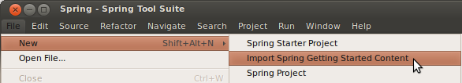
A pop-up wizard will offer you the chance to search and pick any of the published guides from the Spring website. You can either skim the list, or enter search words to instantly filter the options.]
The criteria is applied to both the title and the description when offering instant search results. Wildcards are supported.
You can pick either Maven or Gradle as the build system to use.
You can also decide whether to grab the initial code set, complete code set, or both. For most projects, the initial code set is an empty project, making it possible for you to copy-and-paste your way through a guide. The complete code set is all the code from the guide already entered. If you grab both, you can compare your work against the guide’s and see the differences.
Finally, you can have STS open a browser tab to the guide on the website. This will let you work through a guide without having to leave STS.
For the purpose of this guide, enter rest into the instant search box. Then pick Consuming Rest. Pick Maven for building, and initial and complete code sets. Also opt to open the web page as shown below:
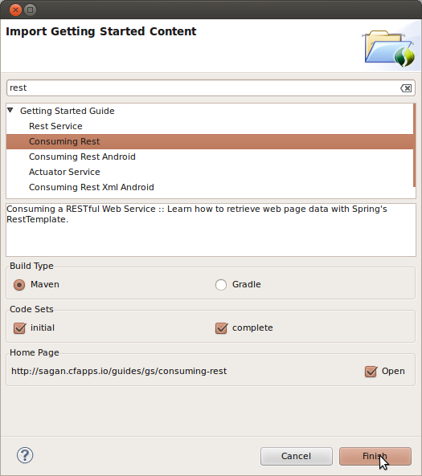
STS will create two new projects in your workspace, import the Consuming Rest code base (both initial and complete), and open a browser tab inside STS as shown below:
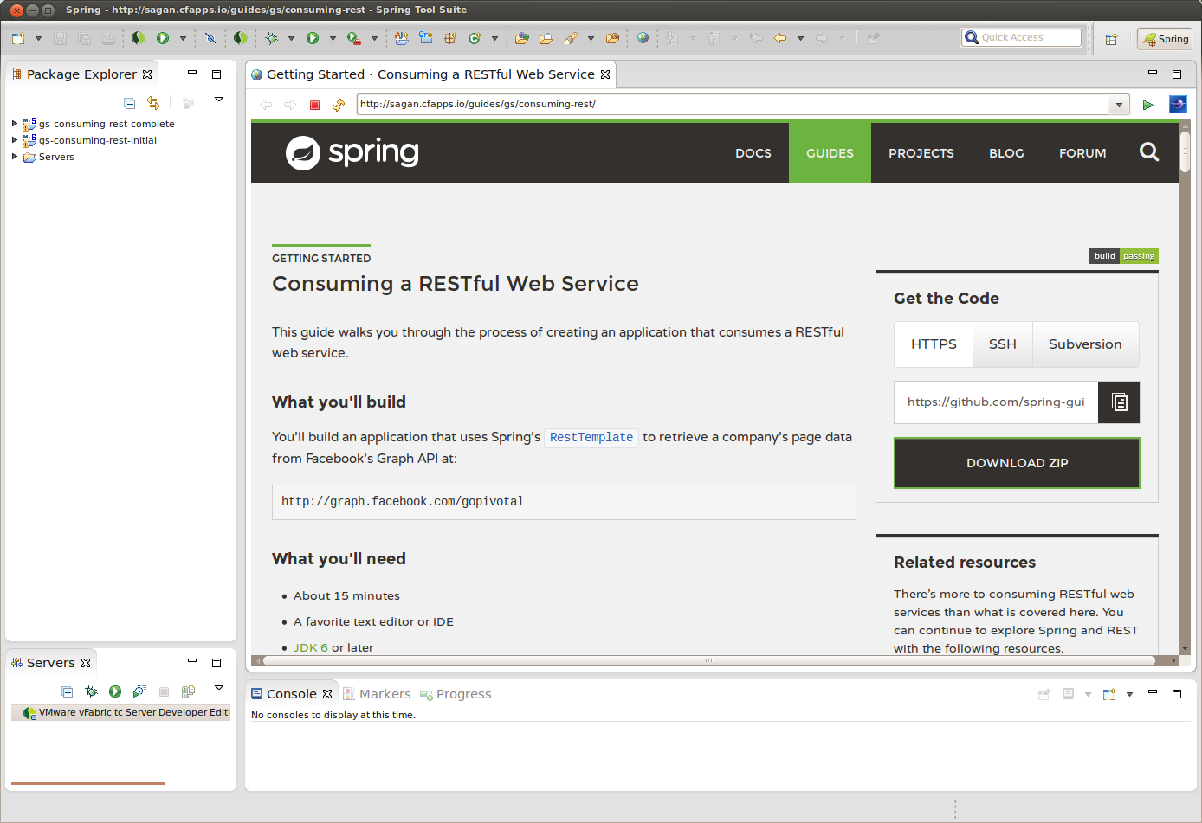
From here, you can walk through the guide and navigate to the code files.

Summary
Congratulations! You have setup Spring Tool Suite, imported the Consuming Rest getting started guide, and opened a browser tab to walk through it.

See Also
The following guides may also be helpful:
- Working a Getting Started guide with IntelliJ IDEA
Want to write a new guide or contribute to an existing one? Check out our contribution guidelines.
All guides are released with an ASLv2 license for the code, and an Attribution, NoDerivatives creative commons license for the writing.

Working a Getting Started guide with IntelliJ IDEA
This guide walks you through using IntelliJ IDEA to build one of the Getting Started guides.

What you’ll build
You’ll pick a Spring guide and import it into IntelliJ IDEA. Then you can read the guide, work on the code, and run the project.

What you’ll need
- About 15 minutes
- IntelliJ IDEA
- JDK 6 or later

Installing IntelliJ IDEA
If you don’t have IntelliJ IDEA (Ultimate Edition) installed yet, visit the link up above. From there, you can download a copy for your platform. To install it simply unpack the downloaded archive.
When you’re done, go ahead and launch IntelliJ IDEA.

Importing a Getting Started guide
To import an existing project you need some code, so clone or copy one of the Getting Started guides, e.g. the REST Service guide:
$ git clone https://github.com/spring-guides/gs-rest-service.git
With IntelliJ IDEA up and running, click Import Project on the Welcome Screen, or File | Open on the main menu:
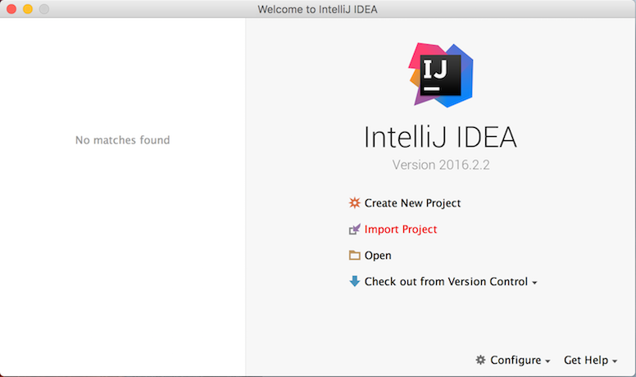
In the pop-up dialog make sure to select either Maven's pom.xml or Gradle's build.gradle file under the complete folder:
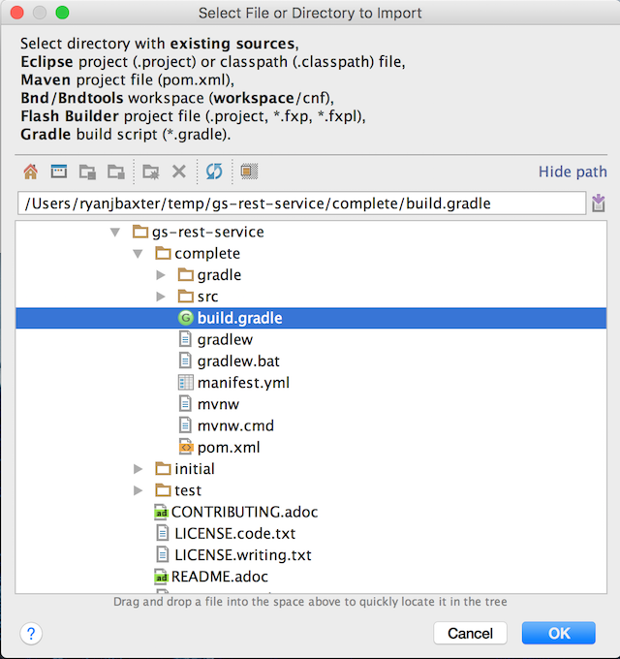
IntelliJ IDEA will create a project with all the code from the guide ready to run.

Creating a Project from Scratch
In case you’d like to start with an empty project and copy-and-paste your way through the guide, create a new Maven or Gradle project in the Project Wizard:
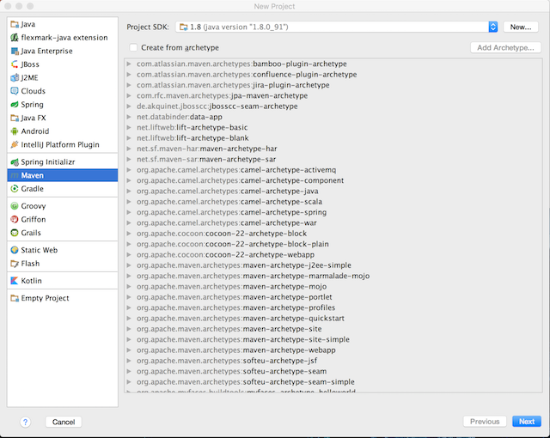

See Also
The following guide may also be helpful:
- Working a Getting Started guide with STS

Learn what you can do with Spring Boot
Spring Boot offers a fast way to build applications. It looks at your classpath and at beans you have configured, makes reasonable assumptions about what you’re missing, and adds it. With Spring Boot you can focus more on business features and less on infrastructure.
For example:
- Got Spring MVC? There are several specific beans you almost always need, and Spring Boot adds them automatically. A Spring MVC app also needs a servlet container, so Spring Boot automatically configures embedded Tomcat.
- Got Jetty? If so, you probably do NOT want Tomcat, but instead embedded Jetty. Spring Boot handles that for you.
- Got Thymeleaf? There are a few beans that must always be added to your application context; Spring Boot adds them for you.
These are just a few examples of the automatic configuration Spring Boot provides. At the same time, Spring Boot doesn’t get in your way. For example, if Thymeleaf is on your path, Spring Boot adds a SpringTemplateEngine to your application context automatically. But if you define your own SpringTemplateEngine with your own settings, then Spring Boot won’t add one. This leaves you in control with little effort on your part.
Spring Boot doesn’t generate code or make edits to your files. Instead, when you start up your application, Spring Boot dynamically wires up beans and settings and applies them to your application context.

Create a simple web application
Now you can create a web controller for a simple web application.
src/main/java/hello/HelloController.java
package hello;

import org.springframework.web.bind.annotation.RestController;
import org.springframework.web.bind.annotation.RequestMapping;

@RestController
public class HelloController {

@RequestMapping("/")
public String index() {
return "Greetings from Spring Boot!";
}

}
The class is flagged as a @RestController, meaning it’s ready for use by Spring MVC to handle web requests. @RequestMapping maps / to the index() method. When invoked from a browser or using curl on the command line, the method returns pure text. That’s because @RestController combines @Controller and @ResponseBody, two annotations that results in web requests returning data rather than a view.

Create an Application class
Here you create an Application class with the components:
src/main/java/hello/Application.java
package hello;

import java.util.Arrays;

import org.springframework.boot.CommandLineRunner;
import org.springframework.boot.SpringApplication;
import org.springframework.boot.autoconfigure.SpringBootApplication;
import org.springframework.context.ApplicationContext;
import org.springframework.context.annotation.Bean;

@SpringBootApplication
public class Application {

public static void main(String[] args) {
SpringApplication.run(Application.class, args);
}

@Bean
public CommandLineRunner commandLineRunner(ApplicationContext ctx) {
return args -> {

System.out.println("Let's inspect the beans provided by Spring Boot:");

String[] beanNames = ctx.getBeanDefinitionNames();
Arrays.sort(beanNames);
for (String beanName : beanNames) {
System.out.println(beanName);
}

};
}

}
@SpringBootApplication is a convenience annotation that adds all of the following:
- @Configuration tags the class as a source of bean definitions for the application context.
- @EnableAutoConfiguration tells Spring Boot to start adding beans based on classpath settings, other beans, and various property settings.
- Normally you would add @EnableWebMvc for a Spring MVC app, but Spring Boot adds it automatically when it sees spring-webmvc on the classpath. This flags the application as a web application and activates key behaviors such as setting up a DispatcherServlet.
- @ComponentScan tells Spring to look for other components, configurations, and services in the hello package, allowing it to find the controllers.
The main() method uses Spring Boot’s SpringApplication.run() method to launch an application. Did you notice that there wasn’t a single line of XML? No web.xml file either. This web application is 100% pure Java and you didn’t have to deal with configuring any plumbing or infrastructure.
There is also a CommandLineRunner method marked as a @Bean and this runs on start up. It retrieves all the beans that were created either by your app or were automatically added thanks to Spring Boot. It sorts them and prints them out.

Run the application
To run the application, execute:
./gradlew build && java -jar build/libs/gs-spring-boot-0.1.0.jar
If you are using Maven, execute:
mvn package && java -jar target/gs-spring-boot-0.1.0.jar
You should see some output like this:
Let's inspect the beans provided by Spring Boot:
application
beanNameHandlerMapping
defaultServletHandlerMapping
dispatcherServlet
embeddedServletContainerCustomizerBeanPostProcessor
handlerExceptionResolver
helloController
httpRequestHandlerAdapter
messageSource
mvcContentNegotiationManager
mvcConversionService
mvcValidator
org.springframework.boot.autoconfigure.MessageSourceAutoConfiguration
org.springframework.boot.autoconfigure.PropertyPlaceholderAutoConfiguration
org.springframework.boot.autoconfigure.web.EmbeddedServletContainerAutoConfiguration
org.springframework.boot.autoconfigure.web.EmbeddedServletContainerAutoConfiguration$DispatcherServletConfiguration
org.springframework.boot.autoconfigure.web.EmbeddedServletContainerAutoConfiguration$EmbeddedTomcat
org.springframework.boot.autoconfigure.web.ServerPropertiesAutoConfiguration
org.springframework.boot.context.embedded.properties.ServerProperties
org.springframework.context.annotation.ConfigurationClassPostProcessor.enhancedConfigurationProcessor
org.springframework.context.annotation.ConfigurationClassPostProcessor.importAwareProcessor
org.springframework.context.annotation.internalAutowiredAnnotationProcessor
org.springframework.context.annotation.internalCommonAnnotationProcessor
org.springframework.context.annotation.internalConfigurationAnnotationProcessor
org.springframework.context.annotation.internalRequiredAnnotationProcessor
org.springframework.web.servlet.config.annotation.DelegatingWebMvcConfiguration
propertySourcesBinder
propertySourcesPlaceholderConfigurer
requestMappingHandlerAdapter
requestMappingHandlerMapping
resourceHandlerMapping
simpleControllerHandlerAdapter
tomcatEmbeddedServletContainerFactory
viewControllerHandlerMapping
You can clearly see org.springframework.boot.autoconfigure beans. There is also a tomcatEmbeddedServletContainerFactory.
Check out the service.
$ curl localhost:8080
Greetings from Spring Boot!

Add Unit Tests
You will want to add a test for the endpoint you added, and Spring Test already provides some machinery for that, and it’s easy to include in your project.
Add this to your build file’s list of dependencies:
testCompile("org.springframework.boot:spring-boot-starter-test")
If you are using Maven, add this to your list of dependencies:
<dependency>
<groupId>org.springframework.boot</groupId>
<artifactId>spring-boot-starter-test</artifactId>
<scope>test</scope>
</dependency>
Now write a simple unit test that mocks the servlet request and response through your endpoint:
src/test/java/hello/HelloControllerTest.java
package hello;

import static org.hamcrest.Matchers.equalTo;
import static org.springframework.test.web.servlet.result.MockMvcResultMatchers.content;
import static org.springframework.test.web.servlet.result.MockMvcResultMatchers.status;

import org.junit.Test;
import org.junit.runner.RunWith;
import org.springframework.beans.factory.annotation.Autowired;
import org.springframework.boot.test.autoconfigure.web.servlet.AutoConfigureMockMvc;
import org.springframework.boot.test.context.SpringBootTest;
import org.springframework.http.MediaType;
import org.springframework.test.context.junit4.SpringRunner;
import org.springframework.test.web.servlet.MockMvc;
import org.springframework.test.web.servlet.request.MockMvcRequestBuilders;

@RunWith(SpringRunner.class)
@SpringBootTest
@AutoConfigureMockMvc
public class HelloControllerTest {

@Autowired
private MockMvc mvc;

@Test
public void getHello() throws Exception {
mvc.perform(MockMvcRequestBuilders.get("/").accept(MediaType.APPLICATION_JSON))
.andExpect(status().isOk())
.andExpect(content().string(equalTo("Greetings from Spring Boot!")));
}
}
The MockMvc comes from Spring Test and allows you, via a set of convenient builder classes, to send HTTP requests into the DispatcherServlet and make assertions about the result. Note the use of the @AutoConfigureMockMvc together with @SpringBootTest to inject a MockMvc instance. Having used @SpringBootTest we are asking for the whole application context to be created. An alternative would be to ask Spring Boot to create only the web layers of the context using the @WebMvcTest. Spring Boot automatically tries to locate the main application class of your application in either case, but you can override it, or narrow it down, if you want to build something different.
As well as mocking the HTTP request cycle we can also use Spring Boot to write a very simple full-stack integration test. For example, instead of (or as well as) the mock test above we could do this:
src/test/java/hello/HelloControllerIT.java
package hello;

import static org.hamcrest.Matchers.*;
import static org.junit.Assert.*;

import java.net.URL;

import org.junit.Before;
import org.junit.Test;
import org.junit.runner.RunWith;
import org.springframework.beans.factory.annotation.Autowired;
import org.springframework.boot.test.context.SpringBootTest;
import org.springframework.boot.test.web.client.TestRestTemplate;
import org.springframework.boot.web.server.LocalServerPort;
import org.springframework.http.ResponseEntity;
import org.springframework.test.context.junit4.SpringRunner;

@RunWith(SpringRunner.class)
@SpringBootTest(webEnvironment = SpringBootTest.WebEnvironment.RANDOM_PORT)
public class HelloControllerIT {

@LocalServerPort
private int port;

private URL base;

@Autowired
private TestRestTemplate template;

@Before
public void setUp() throws Exception {
this.base = new URL("http://localhost:" + port + "/");
}

@Test
public void getHello() throws Exception {
ResponseEntity<String> response = template.getForEntity(base.toString(),
String.class);
assertThat(response.getBody(), equalTo("Greetings from Spring Boot!"));
}
}
The embedded server is started up on a random port by virtue of the webEnvironment = SpringBootTest.WebEnvironment.RANDOM_PORT and the actual port is discovered at runtime with the @LocalServerPort.

Add production-grade services
If you are building a web site for your business, you probably need to add some management services. Spring Boot provides several out of the box with its actuator module, such as health, audits, beans, and more.
Add this to your build file’s list of dependencies:
compile("org.springframework.boot:spring-boot-starter-actuator")
If you are using Maven, add this to your list of dependencies:
<dependency>
<groupId>org.springframework.boot</groupId>
<artifactId>spring-boot-starter-actuator</artifactId>
</dependency>
Then restart the app:
./gradlew build && java -jar build/libs/gs-spring-boot-0.1.0.jar
If you are using Maven, execute:
mvn package && java -jar target/gs-spring-boot-0.1.0.jar
You will see a new set of RESTful end points added to the application. These are management services provided by Spring Boot.
2018-03-17 15:42:20.088 ... : Mapped "{[/error],produces=[text/html]}" onto public org.s...
2018-03-17 15:42:20.089 ... : Mapped "{[/error]}" onto public org.springframework.http.R...
2018-03-17 15:42:20.121 ... : Mapped URL path [/webjars/**] onto handler of type [class ...
2018-03-17 15:42:20.121 ... : Mapped URL path [/**] onto handler of type [class org.spri...
2018-03-17 15:42:20.157 ... : Mapped URL path [/**/favicon.ico] onto handler of type [cl...
2018-03-17 15:42:20.488 ... : Mapped "{[/actuator/health],methods=[GET],produces=[application/vnd...
2018-03-17 15:42:20.490 ... : Mapped "{[/actuator/info],methods=[GET],produces=[application/vnd.s...
2018-03-17 15:42:20.491 ... : Mapped "{[/actuator],methods=[GET],produces=[application/vnd.spring...
They include: errors, actuator/health, actuator/info, actuator.
There is also a /actuator/shutdown endpoint, but it’s only visible by default via JMX. To enable it as an HTTP endpoint, add management.endpoints.shutdown.enabled=true to your application.properties file.
It’s easy to check the health of the app.
$ curl localhost:8080/actuator/health
{"status":"UP"}
You can try to invoke shutdown through curl.
$ curl -X POST localhost:8080/actuator/shutdown
{"timestamp":1401820343710,"error":"Method Not Allowed","status":405,"message":"Request method 'POST' not supported"}
Because we didn’t enable it, the request is blocked by the virtue of not existing.
For more details about each of these REST points and how you can tune their settings with an application.properties file, you can read detailed docs about the endpoints.

View Spring Boot’s starters
You have seen some of Spring Boot’s "starters". You can see them all here in source code.

JAR support and Groovy support
The last example showed how Spring Boot makes it easy to wire beans you may not be aware that you need. And it showed how to turn on convenient management services.
But Spring Boot does yet more. It supports not only traditional WAR file deployments, but also makes it easy to put together executable JARs thanks to Spring Boot’s loader module. The various guides demonstrate this dual support through the spring-boot-gradle-plugin and spring-boot-maven-plugin.
On top of that, Spring Boot also has Groovy support, allowing you to build Spring MVC web apps with as little as a single file.
Create a new file called app.groovy and put the following code in it:
@RestController
class ThisWillActuallyRun {

@RequestMapping("/")
String home() {
return "Hello World!"
}

}
It doesn’t matter where the file is. You can even fit an application that small inside a single tweet!
Next, install Spring Boot’s CLI.
Run it as follows:
$ spring run app.groovy
This assumes you shut down the previous application, to avoid a port collision.
From a different terminal window:
$ curl localhost:8080
Hello World!
Spring Boot does this by dynamically adding key annotations to your code and using Groovy Grape to pull down libraries needed to make the app run.

Summary
Congratulations! You built a simple web application with Spring Boot and learned how it can ramp up your development pace. You also turned on some handy production services. This is only a small sampling of what Spring Boot can do. Checkout Spring Boot’s online docs if you want to dig deeper.

See Also
The following guides may also be helpful:
- Securing a Web Application
- Serving Web Content with Spring MVC
Want to write a new guide or contribute to an existing one? Check out our contribution guidelines.
All guides are released with an ASLv2 license for the code, and an Attribution, NoDerivatives creative commons license for the writing.

